**VISVESVARAYA TECHNOLOGICAL UNIVERSITY**

**“JnanaSangama”, Belgaum -590014, Karnataka.**



**LAB REPORT**

**on**

**MACHINE LEARNING**

**(20CS6PCMAL)**

***Submitted by***

**SAKSHI P KHANDOBA (1BM19CS139)**

***in partial fulfillment for the award of the degree of***

**BACHELOR OF ENGINEERING**

***in***

**COMPUTER SCIENCE AND ENGINEERING**



**B.M.S. COLLEGE OF ENGINEERING**

**(Autonomous Institution under VTU)**

**BENGALURU-560019**

**May-2022 to July-2022**

**B. M. S. College of Engineering,**

**Bull Temple Road, Bangalore 560019**

(Affiliated To Visvesvaraya Technological University, Belgaum)

**Department of Computer Science and Engineering**



**CERTIFICATE**

This is to certify that the Lab work entitled “**Machine Learning**” carried out by **SAKSHI P KHANDOBA (1BM19CS139),** who is a bonafide student of **B. M. S. College of Engineering.** It is in partial fulfillment for the award of **Bachelor of Engineering in Computer Science and Engineering** of the Visvesvaraya Technological University, Belgaum during the year 2022. The Lab report has been approved as it satisfies the academic requirements in respect of **Machine Learning - (20CS6PCMAL)** work prescribed for the said degree.

**Saritha A. N**               **Dr. Jyothi S Nayak**

Assistant Professor Professor and Head

Department of CSE Department of CSE

BMSCE, Bengaluru BMSCE, Bengaluru

`

**Index Sheet**

|  |  |  |
| --- | --- | --- |
| **Sl. No.** | **Experiment Title** | **Page No.** |
|  | **Find-S** |  |
|  | **Candidate Elimination** |  |
|  | **Decision tree based on ID3** |  |
| **4.** | **Naive Bayesian Classifier** |  |
| **5.** | **Linear Regression** |  |
|  |  |  |
|  |  |  |
|  |  |  |
|  |  |  |
|  |  |  |

**Course Outcome**

|  |  |
| --- | --- |
| CO1 | Ability to apply the different learning algorithms |
| CO2 | Ability to analyze the learning techniques for given dataset. |
| CO3 | Ability to design a model using machine learning to solve a problem. |
| CO4 | Ability to conduct practical experiments to solve problems using appropriate machine learning techniques. |

**1. Implement and demonstrate the FIND-S algorithm for finding the most specific hypothesis based on a given set of training data samples.**

**Code:**

import pandas as pd

import numpy as np

data = pd.read_csv("ENJOYSPORT.csv")

print(data,"\n")

*#array of all the attributes*

d = np.array(data)[:,:-1]

print("\n The attributes are: \n",d)

target = np.array(data)[:,-1]

print("\n The target is: ",target)

global specific_hypothesis

def findS(c,t):

for i, val in enumerate(t):

if val == 1:

specific_hypothesis = c[i].copy()

break

for i, val in enumerate(c):

if t[i] == 1:

for x in range(len(specific_hypothesis)):

if val[x] != specific_hypothesis[x]:

specific_hypothesis[x] = '?'

else:

pass

return specific_hypothesis

print("\n The final hypothesis is:",findS(d,target))

**Output:**

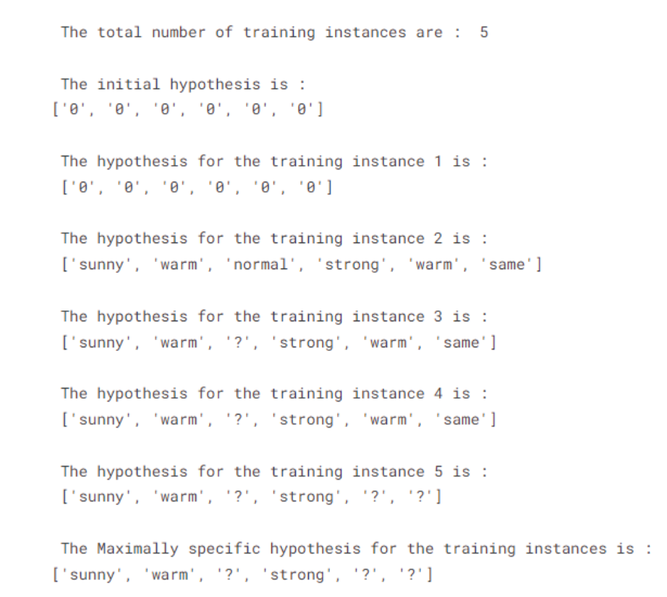

**2. For a given set of training data examples stored in a .CSV file, implement and demonstrate the Candidate-Elimination algorithm to output a description of the set of all hypotheses consistent with the training examples.**

**Code:**

import numpy as np

import pandas as pd

data = pd.DataFrame(data=pd.read_csv('ENJOYSPORT.csv'))

print(data)

print()

concepts = np.array(data.iloc[:,0:-1])

print(concepts)

target = np.array(data.iloc[:,-1])

print("\nTarget: ",target)

def learn(concepts, target):

print("\nInitialization of specific_hypothesis and general_hypothesis:")

specific_h = concepts[0].copy()

print("\nSpecific Hypothesis: ",specific_h)

general_h = [["?" for i in range(len(specific_h))] for i in range(len(specific_h))]

print("\nGeneral Hypothesis: ",general_h)

print("\nSteps of Candidate Elimination Algorithm: \n")

for i, h in enumerate(concepts):

if target[i] == 1:

for x in range(len(specific_h)):

if h[x]!= specific_h[x]:

specific_h[x] ='?'

general_h[x][x] = specific_h[x]

print("Specific: ",specific_h)

print("General: ",general_h)

print()

if target[i] == 0:

for x in range(len(specific_h)):

if h[x] != specific_h[x]:

general_h[x][x] = specific_h[x]

else:

general_h[x][x] = '?'

print("Specific: ",specific_h)

print("General: ",general_h)

print()

indices = [i for i, val in enumerate(general_h) if val == ['?', '?', '?', '?', '?', '?']]

for i in indices:

general_h.remove(['?', '?', '?', '?', '?', '?'])

return specific_h, general_h

s_final, g_final = learn(concepts, target)

print("Final Specific Hypothesis:", s_final, sep="\n")

print("Final General Hypothesis:", g_final, sep="\n")

**Output:**

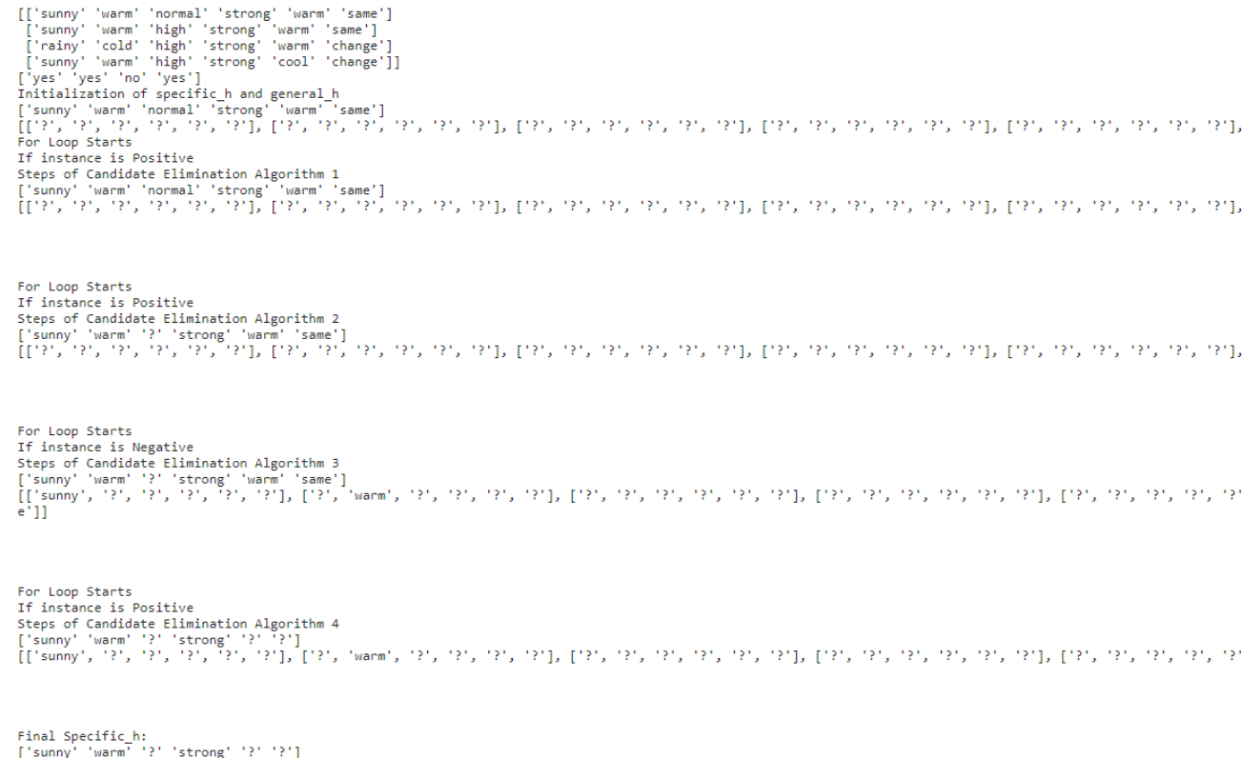

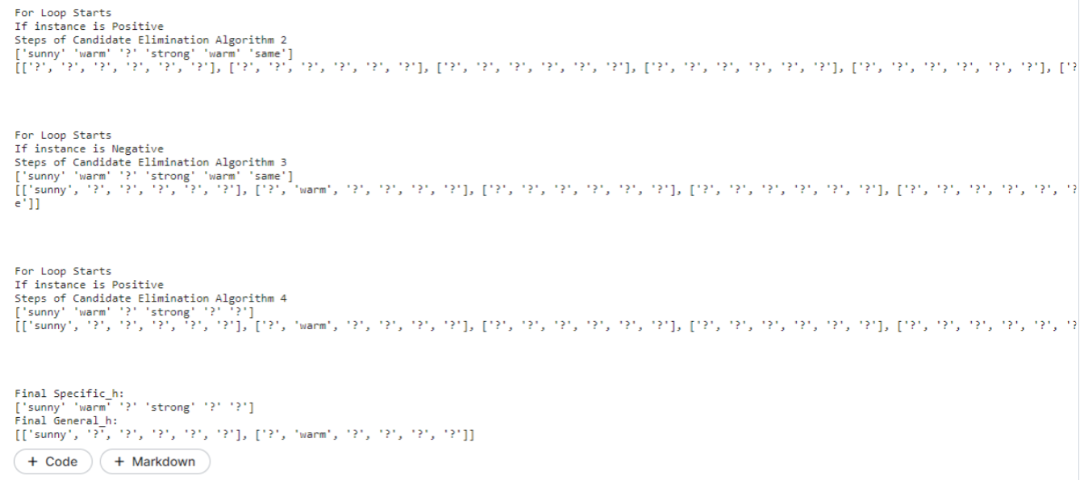

**3. Write a program to demonstrate the working of the decision tree based ID3 algorithm. Use an appropriate data set for building the decision tree and apply this knowledge to classify a new sample.**

**Code:**

|  |
| --- |
|  |
|  | import math  import csv |
|  | def load_csv(filename): |
|  | lines=csv.reader(open(filename,"r")); |
|  | dataset = list(lines) |
|  | headers = dataset.pop(0) |
|  | return dataset,headers |
|  |  |
|  | class Node: |
|  | def __init__(self,attribute): |
|  | self.attribute=attribute |
|  | self.children=[] |
|  | self.answer="" |
|  |  |
|  | def subtables(data,col,delete): |
|  | dic={} |
|  | coldata=[row[col] for row in data] |
|  | attr=list(set(coldata)) |
|  |  |
|  | counts=[0]*len(attr) |
|  | r=len(data) |
|  | c=len(data[0]) |
|  | for x in range(len(attr)): |
|  | for y in range(r): |
|  | if data[y][col]==attr[x]: |
|  | counts[x]+=1 |
|  |  |
|  | for x in range(len(attr)): |
|  | dic[attr[x]]=[[0 for i in range(c)] for j in range(counts[x])] |
|  | pos=0 |
|  | for y in range(r): |
|  | if data[y][col]==attr[x]: |
|  | if delete: |
|  | del data[y][col] |
|  | dic[attr[x]][pos]=data[y] |
|  | pos+=1 |
|  | return attr,dic |
|  |  |
|  | def entropy(S): |
|  | attr=list(set(S)) |
|  | if len(attr)==1: |
|  | return 0 |
|  |  |
|  | counts=[0,0] |
|  | for i in range(2): |
|  | counts[i]=sum([1 for x in S if attr[i]==x])/(len(S)*1.0) |
|  |  |
|  | sums=0 |
|  | for cnt in counts: |
|  | sums+=-1*cnt*math.log(cnt,2) |
|  | return sums |
|  |  |
|  | def compute_gain(data,col): |
|  | attr,dic = subtables(data,col,delete=False) |
|  |  |
|  | total_size=len(data) |
|  | entropies=[0]*len(attr) |
|  | ratio=[0]*len(attr) |
|  |  |
|  | total_entropy=entropy([row[-1] for row in data]) |
|  | for x in range(len(attr)): |
|  | ratio[x]=len(dic[attr[x]])/(total_size*1.0) |
|  | entropies[x]=entropy([row[-1] for row in dic[attr[x]]]) |
|  | total_entropy-=ratio[x]*entropies[x] |
|  | return total_entropy |
|  |  |
|  | def build_tree(data,features): |
|  | lastcol=[row[-1] for row in data] |
|  | if(len(set(lastcol)))==1: |
|  | node=Node("") |
|  | node.answer=lastcol[0] |
|  | return node |
|  |  |
|  | n=len(data[0])-1 |
|  | gains=[0]*n |
|  | for col in range(n): |
|  | gains[col]=compute_gain(data,col) |
|  | split=gains.index(max(gains)) |
|  | node=Node(features[split]) |
|  | fea = features[:split]+features[split+1:] |
|  |  |
|  | attr,dic=subtables(data,split,delete=True) |
|  |  |
|  | for x in range(len(attr)): |
|  | child=build_tree(dic[attr[x]],fea) |
|  | node.children.append((attr[x],child)) |
|  | return node |
|  |  |
|  | def print_tree(node,level): |
|  | if node.answer!="": |
|  | print(" "*level,node.answer) |
|  | return |
|  |  |
|  | print(" "*level,node.attribute) |
|  | for value,n in node.children: |
|  | print(" "*(level+1),"└─",value) |
|  | print_tree(n,level+2) |
|  |  |
|  |  |
|  | '''Main program''' |
|  | dataset,features=load_csv("/kaggle/input/id3-dataset/id3 dataset.csv") |
|  | node1=build_tree(dataset,features) |
|  |  |
|  | print("The decision tree for the dataset using ID3 algorithm is :\n") |
|  | print_tree(node1,0) |

**Output:**

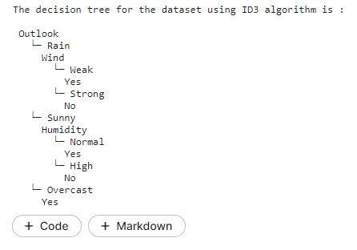

**4. Write a program to implement the naïve Bayesian classifier for a sample training data set stored as a .CSV file. Compute the accuracy of the classifier, considering few test data sets.**

**Code:**

|  |
| --- |
|  |
|  | import pandas as pd  from sklearn.model_selection import train_test_split |
|  | from sklearn.naive_bayes import GaussianNB |
|  | from sklearn import metrics |
|  |  |
|  | df = pd.read_csv("/kaggle/input/diabetes-data/diabetes.csv") |
|  | feature_col_names = ['num_preg', 'glucose_conc', 'diastolic_bp', 'thickness', 'insulin', 'bmi', 'diab_pred', 'age'] |
|  | predicted_class_names = ['diabetes'] |
|  |  |
|  | X = df[feature_col_names].values |
|  | y = df[predicted_class_names].values |
|  |  |
|  | print(df.head) |
|  | xtrain,xtest,ytrain,ytest=train_test_split(X,y,test_size=0.40) |
|  |  |
|  | print ('\n the total number of Training Data :',ytrain.shape) |
|  | print ('\n the total number of Test Data :',ytest.shape) |
|  |  |
|  | clf = GaussianNB().fit(xtrain,ytrain.ravel()) |
|  | predicted = clf.predict(xtest) |
|  | predictTestData= clf.predict([[6,148,72,35,0,33.6,0.627,50]]) |
|  |  |
|  | print('\n Confusion matrix') |
|  | print(metrics.confusion_matrix(ytest,predicted)) |
|  |  |
|  | print('\n Accuracy of the classifier is',metrics.accuracy_score(ytest,predicted)) |
|  |  |
|  | print('\n The value of Precision', metrics.precision_score(ytest,predicted)) |
|  |  |
|  | print('\n The value of Recall', metrics.recall_score(ytest,predicted)) |
|  |  |
|  | print("Predicted Value for individual Test Data:", predictTestData) |

**Output:**

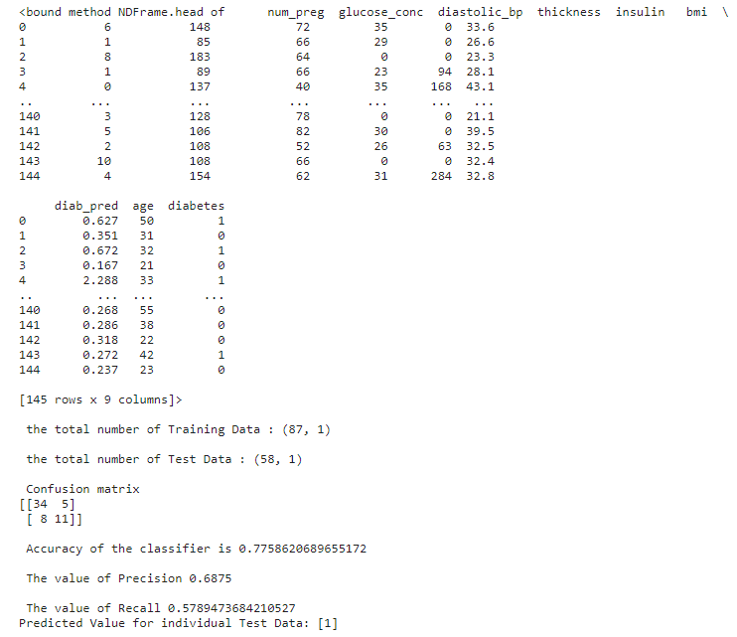

**5. Write a program to construct a Bayesian network considering training data. Use this model to make predictions.**

**Code:**

**Linear Regression with dataset:**

|  |
| --- |
|  |
|  | Import numpy as np  import matplotlib.pyplot as plt |
|  | import pandas as pd |
|  |  |
|  | # Importing the dataset |
|  | dataset = pd.read_csv('/kaggle/input/years-of-experience-and-salary/Years Experience and Salary.csv') |
|  | X = dataset.iloc[:, :-1].values #get a copy of dataset exclude last column |
|  | y = dataset.iloc[:, 1].values #get array of dataset in column 1st |
|  |  |
|  | # Splitting the dataset into the Training set and Test set |
|  | from sklearn.model_selection import train_test_split |
|  | X_train, X_test, y_train, y_test = train_test_split(X, y, test_size=1/3, random_state=0) |
|  |  |
|  |  |
|  |  |
|  | # Fitting Simple Linear Regression to the Training set |
|  | from sklearn.linear_model import LinearRegression |
|  | regressor = LinearRegression() |
|  | regressor.fit(X_train, y_train) |
|  |  |
|  | # Predicting the Test set results |
|  | y_pred = regressor.predict(X_test) |
|  |  |
|  | # Visualizing the Training set results |
|  | viz_train = plt |
|  | viz_train.scatter(X_train, y_train, color='red') |
|  | viz_train.plot(X_train, regressor.predict(X_train), color='blue') |
|  | viz_train.title('Salary VS Experience (Training set)') |
|  | viz_train.xlabel('Year of Experience') |
|  | viz_train.ylabel('Salary') |
|  | viz_train.show() |
|  |  |
|  | # Visualizing the Test set results |
|  | viz_test = plt |
|  | viz_test.scatter(X_test, y_test, color='red') |
|  | viz_test.plot(X_train, regressor.predict(X_train), color='blue') |
|  | viz_test.title('Salary VS Experience (Test set)') |
|  | viz_test.xlabel('Year of Experience') |
|  | viz_test.ylabel('Salary') |
|  | viz_test.show() |

**Linear Regression:**

|  |
| --- |
|  |
|  | import numpy as np  import matplotlib.pyplot as plt |
|  |  |
|  | def estimate_coef(x, y): |
|  | # number of observations/points |
|  | n = np.size(x) |
|  |  |
|  | # mean of x and y vector |
|  | m_x = np.mean(x) |
|  | m_y = np.mean(y) |
|  |  |
|  | # calculating cross-deviation and deviation about x |
|  | SS_xy = np.sum(y*x) - n*m_y*m_x |
|  | SS_xx = np.sum(x*x) - n*m_x*m_x |
|  |  |
|  | # calculating regression coefficients |
|  | b_1 = SS_xy / SS_xx |
|  | b_0 = m_y - b_1*m_x |
|  |  |
|  | return (b_0, b_1) |
|  |  |
|  | def plot_regression_line(x, y, b): |
|  | # plotting the actual points as scatter plot |
|  | plt.scatter(x, y, color = "m", |
|  | marker = "o", s = 30) |
|  |  |
|  | # predicted response vector |
|  | y_pred = b[0] + b[1]*x |
|  |  |
|  | # plotting the regression line |
|  | plt.plot(x, y_pred, color = "g") |
|  |  |
|  | # putting labels |
|  | plt.xlabel('x') |
|  | plt.ylabel('y') |
|  |  |
|  | # function to show plot |
|  | plt.show() |
|  |  |
|  | def main(): |
|  | # observations / data |
|  | x = np.array([0, 1, 2, 3, 4, 5, 6, 7, 8, 9]) |
|  | y = np.array([1, 3, 2, 5, 7, 8, 8, 9, 10, 12]) |
|  |  |
|  | # estimating coefficients |
|  | b = estimate_coef(x, y) |
|  | print("Estimated coefficients:\nb_0 = {} \ |
|  | \nb_1 = {}".format(b[0], b[1])) |
|  |  |
|  | # plotting regression line |
|  | plot_regression_line(x, y, b) |
|  |  |
|  | if __name__ == "__main__": |
|  | main() |

**Output:**

